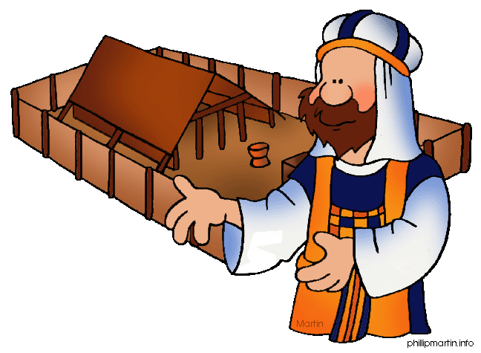**Message Outline**

*Leviticus: Reviewing Leviticus*

**Leviticus 1-27**

________________________________________________________________________________________________________________________________________________________________________________________________________________________________________________________________________________________________________________________________________________________________________________________________________________________________________________________________________________________________________________________________________________________________________________________________________________________________________________________________________________________________________________________________

**Message Outline**

*Leviticus: Reviewing Leviticus*

**Leviticus 1-27**

________________________________________________________________________________________________________________________________________________________________________________________________________________________________________________________________________________________________________________________________________________________________________________________________________________________________________________________________________________________________________________________________________________________________________________________________________________________________________________________________________________________________________________________________

**Message Outline**

*Leviticus: Reviewing Leviticus*

**Leviticus 1-27**

________________________________________________________________________________________________________________________________________________________________________________________________________________________________________________________________________________________________________________________________________________________________________________________________________________________________________________________________________________________________________________________________________________________________________________________________________________________________________________________________________________________________________________________________

 **Small Group**

**Reflection Questions**

(Please take time to ponder and pencil in

to prep for this week’s small group session.)

***\*This is the last week of our fall small group session, which means…***

*\*****GROUP CHOICE WEEK!!!***

*\*Review your favorite Chosen scenes…*

*or*

*\*Return to a class discussion you didn’t have enough time for…*

*or*

*\*Play a group game…*

*or*

*\*Throw a party…*

***\*MARK YOUR CALENDARS!!!***

*-****Sunday, December 10*** *from 5-7pm in the Life Center for our Christmas Small Group mixer with all the small groups of the church…and yes, there will be both food and fun!!!*

*-The* ***week of January 7*** *begins our winter/spring small group session!!!*

***\*Pray!*** *Take time to pray together as a group as we end our fall session together...*

 **Small Group**

**Reflection Questions**

(Please take time to ponder and pencil in

to prep for this week’s small group session.)

***\*This is the last week of our fall small group session, which means…***

*\*****GROUP CHOICE WEEK!!!***

*\*Review your favorite Chosen scenes…*

*or*

*\*Return to a class discussion you didn’t have enough time for…*

*or*

*\*Play a group game…*

*or*

*\*Throw a party…*

***\*MARK YOUR CALENDARS!!!***

*-****Sunday, December 10*** *from 5-7pm in the Life Center for our Christmas Small Group mixer with all the small groups of the church…and yes, there will be both food and fun!!!*

*-The* ***week of January 7*** *begins our winter/spring small group session!!!*

***\*Pray!*** *Take time to pray together as a group as we end our fall session together...*

 **Small Group**

**Reflection Questions**

(Please take time to ponder and pencil in

to prep for this week’s small group session.)

***\*This is the last week of our fall small group session, which means…***

*\*****GROUP CHOICE WEEK!!!***

*\*Review your favorite Chosen scenes…*

*or*

*\*Return to a class discussion you didn’t have enough time for…*

*or*

*\*Play a group game…*

*or*

*\*Throw a party…*

***\*MARK YOUR CALENDARS!!!***

*-****Sunday, December 10*** *from 5-7pm in the Life Center for our Christmas Small Group mixer with all the small groups of the church…and yes, there will be both food and fun!!!*

*-The* ***week of January 7*** *begins our winter/spring small group session!!!*

***\*Pray!*** *Take time to pray together as a group as we end our fall session together...*