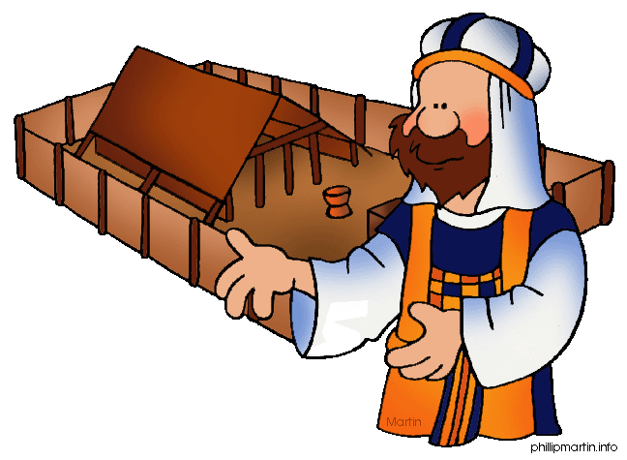**Message Outline**

*Leviticus: Celebration Time*

**Leviticus 26-27**

**Intro:** Nearing the end of Leviticus series…

* Last week…“celebrate good times” (Lev.23-25)!!!
* Next week…reviewing key themes…

**Read:** Leviticus 26

**v.1—**We become like what we worship…

* Worshipping the Giver of Life becomes life-giving…

**v.2—**Sabbaths and sanctuary as key indicators on if we are seek God or idols!!!

**v.3-13—**If/then scenarios…God’s cause and effect cosmos…

a) P__________________v.1-3 (Mt.6:33)

b) P__________________v.4-5

c) P__________________v.6-8

d) P__________________v.9-13

***Obedience to the Giver of Life is Life- Giving!!!

**v.14-39—**The flip-side of the coin…

* Disobedience to the Giver of Life destroys life…

**v.40-46—**The God of second chances…

* Confessing sin (v.40)…
* Covenantal remembrance (v.42)…

**Read:** Leviticus 27

* Leviticus began with sacrifices and ends with special vows and dedicated things to God…
* An appendix on slavery in Scripture…

**Lessons on Leviticus 26-27…**

1) ___________________________________

* God invented life and truly knows what’s best for life!

2) ___________________________________

* Living all in with God (cf. Rom.12:1-2)…

**Message Outline**

*Leviticus: Celebration Time*

**Leviticus 26-27**

**Intro:** Nearing the end of Leviticus series…

* Last week…“celebrate good times” (Lev.23-25)!!!
* Next week…reviewing key themes…

**Read:** Leviticus 26

**v.1—**We become like what we worship…

* Worshipping the Giver of Life becomes life-giving…

**v.2—**Sabbaths and sanctuary as key indicators on if we are seek God or idols!!!

**v.3-13—**If/then scenarios…God’s cause and effect cosmos…

a) P__________________v.1-3 (Mt.6:33)

b) P__________________v.4-5

c) P__________________v.6-8

d) P__________________v.9-13

***Obedience to the Giver of Life is Life- Giving!!!

**v.14-39—**The flip-side of the coin…

* Disobedience to the Giver of Life destroys life…

**v.40-46—**The God of second chances…

* Confessing sin (v.40)…
* Covenantal remembrance (v.42)…

**Read:** Leviticus 27

* Leviticus began with sacrifices and ends with special vows and dedicated things to God…
* An appendix on slavery in Scripture…

**Lessons on Leviticus 26-27…**

1) ___________________________________

* God invented life and truly knows what’s best for life!

2) ___________________________________

* Living all in with God (cf. Rom.12:1-2)…

**Message Outline**

*Leviticus: Celebration Time*

**Leviticus 26-27**

**Intro:** Nearing the end of Leviticus series…

* Last week…“celebrate good times” (Lev.23-25)!!!
* Next week…reviewing key themes…

**Read:** Leviticus 26

**v.1—**We become like what we worship…

* Worshipping the Giver of Life becomes life-giving…

**v.2—**Sabbaths and sanctuary as key indicators on if we are seek God or idols!!!

**v.3-13—**If/then scenarios…God’s cause and effect cosmos…

a) P__________________v.1-3 (Mt.6:33)

b) P__________________v.4-5

c) P__________________v.6-8

d) P__________________v.9-13

***Obedience to the Giver of Life is Life- Giving!!!

**v.14-39—**The flip-side of the coin…

* Disobedience to the Giver of Life destroys life…

**v.40-46—**The God of second chances…

* Confessing sin (v.40)…
* Covenantal remembrance (v.42)…

**Read:** Leviticus 27

* Leviticus began with sacrifices and ends with special vows and dedicated things to God…
* An appendix on slavery in Scripture…

**Lessons on Leviticus 26-27…**

1) ___________________________________

* God invented life and truly knows what’s best for life!

2) ___________________________________

* Living all in with God (cf. Rom.12:1-2)…

 **Small Group**

**Reflection Questions**

(Please take time to ponder and pencil in

to prep for this week’s small group session.)

*\*****Watch:*** *Ep.3 “Physician Heal Yourself” (~50min.). What most caught your attention watching this episode?*

*\*Although Jesus is fully God and Eternal (100% Divine!), He was also raised and grew up as a child (100% Human!). Why do you think it’s important to remember Jesus was raised by Mary and Joseph?*

*\*What do you notice about the way Jesus is received when He returns to His hometown (both the good and bad reactions)? Do you have places you are received positively? Do you have places you are received poorly?*

 **Small Group**

**Reflection Questions**

(Please take time to ponder and pencil in

to prep for this week’s small group session.)

*\*****Watch:*** *Ep.3 “Physician Heal Yourself” (~50min.). What most caught your attention watching this episode?*

*\*Although Jesus is fully God and Eternal (100% Divine!), He was also raised and grew up as a child (100% Human!). Why do you think it’s important to remember Jesus was raised by Mary and Joseph?*

*\*What do you notice about the way Jesus is received when He returns to His hometown (both the good and bad reactions)? Do you have places you are received positively? Do you have places you are received poorly?*

 **Small Group**

**Reflection Questions**

(Please take time to ponder and pencil in

to prep for this week’s small group session.)

*\*****Watch:*** *Ep.3 “Physician Heal Yourself” (~50min.). What most caught your attention watching this episode?*

*\*Although Jesus is fully God and Eternal (100% Divine!), He was also raised and grew up as a child (100% Human!). Why do you think it’s important to remember Jesus was raised by Mary and Joseph?*

*\*What do you notice about the way Jesus is received when He returns to His hometown (both the good and bad reactions)? Do you have places you are received positively? Do you have places you are received poorly?*