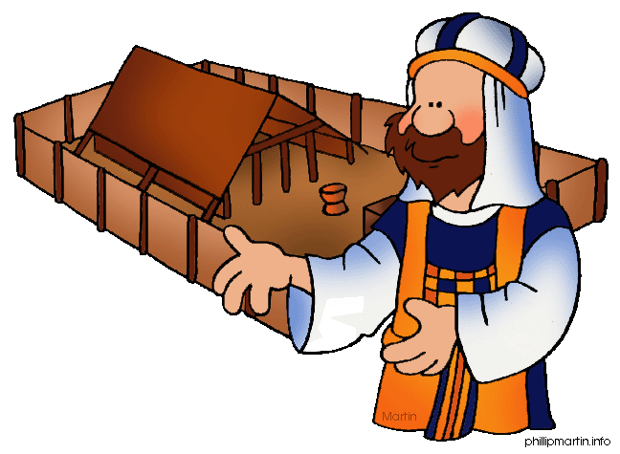**Message Outline**

*Leviticus: Celebration Time*

**Leviticus 23-25**

**Intro:** Nearing the end of Leviticus series…

* Last week, challenging topics with children, personal finances, personal handicaps, etc.
* This week, commanded celebrations!!!

**Read:** Leviticus 23

**v.1-2—**God commanding a good time…He’s not a cosmic killjoy!

**v.3—**Sabbath as a weekly holiday…

**v.4—**Tracking months in the Bible…

**v.5-8—**A 7 day party reminding of salvation from Egypt…

**v.9-14—**Firstfruits and “praying” before eating…

**v.15-21—**Celebrating where stuff comes from…a harvest holiday.

**v.22—**Israelite “welfare” system(Lev.19:9-10).

**v.23-25—**Significance of 7th month…

* Month starts with trumpet and taking day off of work…

**v.26-32—**Day of Atonement and somber celebration (cf. Lev.16)…

**v.33-44—**“Church” in a “tent” and significance of temporary shelters…

**Read:** Leviticus 24

* When the celebration gets interrupted…
* God’s judgment on blaspheme (cf. 1Tim.1:13)…

**Read:** Leviticus 25

* Sabbath Year and keeping land fertile (v.1-7, 18-22)…
* Year of Jubilee and new beginnings, community, and economic benefits (v.8-55).

**Lessons on Leviticus 23-25…**

1) ___________________________________

2) ___________________________________

3) ___________________________________

**Message Outline**

*Leviticus: Celebration Time*

**Leviticus 23-25**

**Intro:** Nearing the end of Leviticus series…

* Last week, challenging topics with children, personal finances, personal handicaps, etc.
* This week, commanded celebrations!!!

**Read:** Leviticus 23

**v.1-2—**God commanding a good time…He’s not a cosmic killjoy!

**v.3—**Sabbath as a weekly holiday…

**v.4—**Tracking months in the Bible…

**v.5-8—**A 7 day party reminding of salvation from Egypt…

**v.9-14—**Firstfruits and “praying” before eating…

**v.15-21—**Celebrating where stuff comes from…a harvest holiday.

**v.22—**Israelite “welfare” system(Lev.19:9-10).

**v.23-25—**Significance of 7th month…

* Month starts with trumpet and taking day off of work…

**v.26-32—**Day of Atonement and somber celebration (cf. Lev.16)…

**v.33-44—**“Church” in a “tent” and significance of temporary shelters…

**Read:** Leviticus 24

* When the celebration gets interrupted…
* God’s judgment on blaspheme (cf. 1Tim.1:13)…

**Read:** Leviticus 25

* Sabbath Year and keeping land fertile (v.1-7, 18-22)…
* Year of Jubilee and new beginnings, community, and economic benefits (v.8-55).

**Lessons on Leviticus 23-25…**

1) ___________________________________

2) ___________________________________

3) ___________________________________

**Message Outline**

*Leviticus: Celebration Time*

**Leviticus 23-25**

**Intro:** Nearing the end of Leviticus series…

* Last week, challenging topics with children, personal finances, personal handicaps, etc.
* This week, commanded celebrations!!!

**Read:** Leviticus 23

**v.1-2—**God commanding a good time…He’s not a cosmic killjoy!

**v.3—**Sabbath as a weekly holiday…

**v.4—**Tracking months in the Bible…

**v.5-8—**A 7 day party reminding of salvation from Egypt…

**v.9-14—**Firstfruits and “praying” before eating…

**v.15-21—**Celebrating where stuff comes from…a harvest holiday.

**v.22—**Israelite “welfare” system(Lev.19:9-10).

**v.23-25—**Significance of 7th month…

* Month starts with trumpet and taking day off of work…

**v.26-32—**Day of Atonement and somber celebration (cf. Lev.16)…

**v.33-44—**“Church” in a “tent” and significance of temporary shelters…

**Read:** Leviticus 24

* When the celebration gets interrupted…
* God’s judgment on blaspheme (cf. 1Tim.1:13)…

**Read:** Leviticus 25

* Sabbath Year and keeping land fertile (v.1-7, 18-22)…
* Year of Jubilee and new beginnings, community, and economic benefits (v.8-55).

**Lessons on Leviticus 23-25…**

1) ___________________________________

2) ___________________________________

3) ___________________________________

 **Small Group**

**Reflection Questions**

(Please take time to ponder and pencil in

to prep for this week’s small group session.)

*Next week’s Chosen episode is going to deal with Jesus returning to His hometown. Here are some hometown questions for you to reflect on this week…*

*\*Describe your hometown (ie. name, size, setting, friends, what you did for fun growing up, etc.).*

*\*What was your favorite part of growing up in your hometown? What did you dislike about your hometown?*

*\*Did you have a best friend growing up? Who was it and why did you become friends?*

*\*****Read together*** *as a group: Luke 4:14-30, John 7:1-5, (and if time permits John 11). What details of Jesus’ hometown/family/friends did you notice in these Scriptures?*

 **Small Group**

**Reflection Questions**

(Please take time to ponder and pencil in

to prep for this week’s small group session.)

*Next week’s Chosen episode is going to deal with Jesus returning to His hometown. Here are some hometown questions for you to reflect on this week…*

*\*Describe your hometown (ie. name, size, setting, friends, what you did for fun growing up, etc.).*

*\*What was your favorite part of growing up in your hometown? What did you dislike about your hometown?*

*\*Did you have a best friend growing up? Who was it and why did you become friends?*

*\*****Read together*** *as a group: Luke 4:14-30, John 7:1-5, (and if time permits John 11). What details of Jesus’ hometown/family/friends did you notice in these Scriptures?*

 **Small Group**

**Reflection Questions**

(Please take time to ponder and pencil in

to prep for this week’s small group session.)

*Next week’s Chosen episode is going to deal with Jesus returning to His hometown. Here are some hometown questions for you to reflect on this week…*

*\*Describe your hometown (ie. name, size, setting, friends, what you did for fun growing up, etc.).*

*\*What was your favorite part of growing up in your hometown? What did you dislike about your hometown?*

*\*Did you have a best friend growing up? Who was it and why did you become friends?*

*\*****Read together*** *as a group: Luke 4:14-30, John 7:1-5, (and if time permits John 11). What details of Jesus’ hometown/family/friends did you notice in these Scriptures?*