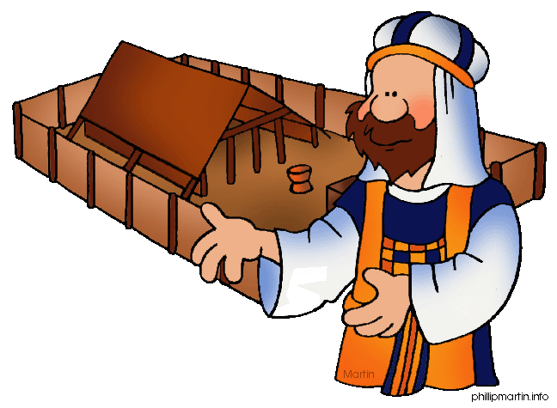**Message Outline**

*Leviticus: Laws in Life*

**Leviticus 19**

**Intro:** Last week, missionaries from PNG…

* Last time in Leviticus was Lev.18 and sermon on human sexuality…
* Today an assortment of instructions that deal with various life matters in Leviticus 19…

**Read:** Leviticus 19

**v.1-2—**A call to holiness not just an OT thing (cf.Heb.12:14, Rom.6:22-23, Eph.4:20- 24, 1Pet.1:15-16)…

* The need for the *Holy* Spirit in *holy* living (cf. Eph.1:13-14)…

**v.3-37—**Q & A…

______________________________________________________________________________________________________________________________________________________________________________________________________________________________________________________________________________________________________________________________________________________________________________________________________________________________________________________________________________________________________________________________________________________________________________________________________________________________________________________________________

**Message Outline**

*Leviticus: Laws in Life*

**Leviticus 19**

**Intro:** Last week, missionaries from PNG…

* Last time in Leviticus was Lev.18 and sermon on human sexuality…
* Today an assortment of instructions that deal with various life matters in Leviticus 19…

**Read:** Leviticus 19

**v.1-2—**A call to holiness not just an OT thing (cf.Heb.12:14, Rom.6:22-23, Eph.4:20- 24, 1Pet.1:15-16)…

* The need for the *Holy* Spirit in *holy* living (cf. Eph.1:13-14)…

**v.3-37—**Q & A…

______________________________________________________________________________________________________________________________________________________________________________________________________________________________________________________________________________________________________________________________________________________________________________________________________________________________________________________________________________________________________________________________________________________________________________________________________________________________________________________________________

**Message Outline**

*Leviticus: Laws in Life*

**Leviticus 19**

**Intro:** Last week, missionaries from PNG…

* Last time in Leviticus was Lev.18 and sermon on human sexuality…
* Today an assortment of instructions that deal with various life matters in Leviticus 19…

**Read:** Leviticus 19

**v.1-2—**A call to holiness not just an OT thing (cf.Heb.12:14, Rom.6:22-23, Eph.4:20- 24, 1Pet.1:15-16)…

* The need for the *Holy* Spirit in *holy* living (cf. Eph.1:13-14)…

**v.3-37—**Q & A…

______________________________________________________________________________________________________________________________________________________________________________________________________________________________________________________________________________________________________________________________________________________________________________________________________________________________________________________________________________________________________________________________________________________________________________________________________________________________________________________________________

 **Small Group**

**Reflection Questions**

(Please take time to ponder and pencil in

to prep for this week’s small group session.)

*\*****Watch:*** *Ep.2 “Two by Two” (Part 1--48min.). What most caught your attention watching this episode?*

*\*Talk about the various reactions of Jesus’ disciples at His plan to send them out two by two in ministry. How do you see yourself in some of their responses? How would you respond to Jesus sending you in ministry?*

*\*Jesus had some odd pairings—big James/little James, Simon the rock/Judas the betrayer, Matthew the tax collector/Simon the Zealot. Why is that significant? How can we grow in relationships with those we may struggle with? Is there an “odd pairing” in your life today you think God might be using to shape you through?*

 **Small Group**

**Reflection Questions**

(Please take time to ponder and pencil in

to prep for this week’s small group session.)

*\*****Watch:*** *Ep.2 “Two by Two” (Part 1--48min.). What most caught your attention watching this episode?*

*\*Talk about the various reactions of Jesus’ disciples at His plan to send them out two by two in ministry. How do you see yourself in some of their responses? How would you respond to Jesus sending you in ministry?*

*\*Jesus had some odd pairings—big James/little James, Simon the rock/Judas the betrayer, Matthew the tax collector/Simon the Zealot. Why is that significant? How can we grow in relationships with those we may struggle with? Is there an “odd pairing” in your life today you think God might be using to shape you through?*

 **Small Group**

**Reflection Questions**

(Please take time to ponder and pencil in

to prep for this week’s small group session.)

*\*****Watch:*** *Ep.2 “Two by Two” (Part 1--48min.). What most caught your attention watching this episode?*

*\*Talk about the various reactions of Jesus’ disciples at His plan to send them out two by two in ministry. How do you see yourself in some of their responses? How would you respond to Jesus sending you in ministry?*

*\*Jesus had some odd pairings—big James/little James, Simon the rock/Judas the betrayer, Matthew the tax collector/Simon the Zealot. Why is that significant? How can we grow in relationships with those we may struggle with? Is there an “odd pairing” in your life today you think God might be using to shape you through?*