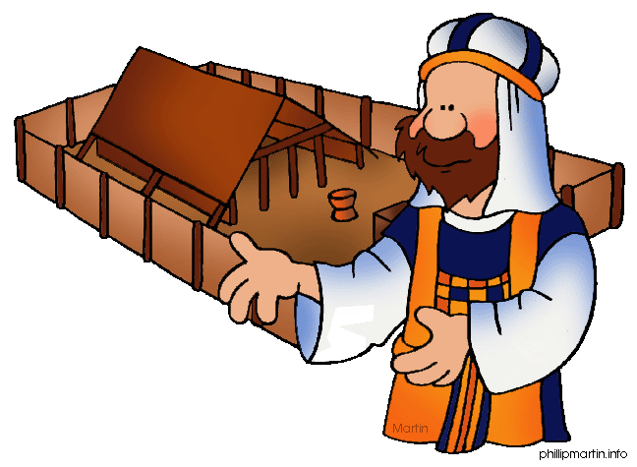**Message Outline**

*Leviticus: Day of Atonement*

**Leviticus 16-17**

**Intro:** Midway point of Leviticus series…

* Review of Leviticus: [www.bibleproject.com/explore/video/torah-leviticus/](http://www.bibleproject.com/explore/video/torah-leviticus/)
* Today, as we cover Lev.16-17, it’s literally Yom Kippur (the Day of Atonement)…

**Read:** Leviticus 16-17

**v.1-2—**Calls us back to Nadab and Abihu in Leviticus 10…

* We don’t approach God on our terms but His terms!

**v.3—**Dealing with personal sin thru sacrifice…

**v.4—**Clothing matters (cf.Lev.8-9, Rom.13:14)

* Servant’s clothes and echoing Jesus and the cross (cf. Jn.13, 19:23-24)…

**v.5—**Priest as representative…

**v.6-10—**2 goats: 1 sacrificed, 1 released (cf. Heb.10)…

**v.11-14—**Behind the curtain…Holy of Holies.

**v.15-19—**Making atonement for Holy Place…

* Even “church” gets tainted by human sin…

**v.20-21—**National confession of corporate sin.

**v.22-28—**Taken out and totally burned…

**v.29-35—**National holiday…

**17:1-9—**Value of “credentialing”…

**v.10-14—**Connection between life and blood...

**v.15-16—**Hygienic purposes…

**Lessons on CHURCH from Leviticus**

1) ________________________________v.34

* Atonement is necessary for sinful people to access a Holy God!

2) _______________________________v.6-7

* Needing to deal with personal sin before corporate sin (cf. Mt.7:3-5)…

3) ___________________________________

* The symbolism between the two goats…
* The sacrifice of Jesus so we go free…
* cf. Hebrews 9-10…

**Message Outline**

*Leviticus: Day of Atonement*

**Leviticus 16-17**

**Intro:** Midway point of Leviticus series…

* Review of Leviticus: [www.bibleproject.com/explore/video/torah-leviticus/](http://www.bibleproject.com/explore/video/torah-leviticus/)
* Today, as we cover Lev.16-17, it’s literally Yom Kippur (the Day of Atonement)…

**Read:** Leviticus 16-17

**v.1-2—**Calls us back to Nadab and Abihu in Leviticus 10…

* We don’t approach God on our terms but His terms!

**v.3—**Dealing with personal sin thru sacrifice…

**v.4—**Clothing matters (cf.Lev.8-9, Rom.13:14)

* Servant’s clothes and echoing Jesus and the cross (cf. Jn.13, 19:23-24)…

**v.5—**Priest as representative…

**v.6-10—**2 goats: 1 sacrificed, 1 released (cf. Heb.10)…

**v.11-14—**Behind the curtain…Holy of Holies.

**v.15-19—**Making atonement for Holy Place…

* Even “church” gets tainted by human sin…

**v.20-21—**National confession of corporate sin.

**v.22-28—**Taken out and totally burned…

**v.29-35—**National holiday…

**17:1-9—**Value of “credentialing”…

**v.10-14—**Connection between life and blood...

**v.15-16—**Hygienic purposes…

**Lessons on CHURCH from Leviticus**

1) ________________________________v.34

* Atonement is necessary for sinful people to access a Holy God!

2) _______________________________v.6-7

* Needing to deal with personal sin before corporate sin (cf. Mt.7:3-5)…

3) ___________________________________

* The symbolism between the two goats…
* The sacrifice of Jesus so we go free…
* cf. Hebrews 9-10…

**Message Outline**

*Leviticus: Day of Atonement*

**Leviticus 16-17**

**Intro:** Midway point of Leviticus series…

* Review of Leviticus: [www.bibleproject.com/explore/video/torah-leviticus/](http://www.bibleproject.com/explore/video/torah-leviticus/)
* Today, as we cover Lev.16-17, it’s literally Yom Kippur (the Day of Atonement)…

**Read:** Leviticus 16-17

**v.1-2—**Calls us back to Nadab and Abihu in Leviticus 10…

* We don’t approach God on our terms but His terms!

**v.3—**Dealing with personal sin thru sacrifice…

**v.4—**Clothing matters (cf.Lev.8-9, Rom.13:14)

* Servant’s clothes and echoing Jesus and the cross (cf. Jn.13, 19:23-24)…

**v.5—**Priest as representative…

**v.6-10—**2 goats: 1 sacrificed, 1 released (cf. Heb.10)…

**v.11-14—**Behind the curtain…Holy of Holies.

**v.15-19—**Making atonement for Holy Place…

* Even “church” gets tainted by human sin…

**v.20-21—**National confession of corporate sin.

**v.22-28—**Taken out and totally burned…

**v.29-35—**National holiday…

**17:1-9—**Value of “credentialing”…

**v.10-14—**Connection between life and blood...

**v.15-16—**Hygienic purposes…

**Lessons on CHURCH from Leviticus**

1) ________________________________v.34

* Atonement is necessary for sinful people to access a Holy God!

2) _______________________________v.6-7

* Needing to deal with personal sin before corporate sin (cf. Mt.7:3-5)…

3) ___________________________________

* The symbolism between the two goats…
* The sacrifice of Jesus so we go free…
* cf. Hebrews 9-10…

 **Small Group**

**Reflection Questions**

(Please take time to ponder and pencil in

to prep for this week’s small group session.)

*\*Name a “whoop” and a “poop” from this past week (ie. “highlight/lowlight”).*

*\*As a group, take some time to review some characters/events of The Chosen Season 1&2 from last year. Here’s some help…*

*-Jesus*

*-Mary Magdalene*

*-Peter/Andrew*

*-James/John*

*-Simon the Zealot*

*-Matthew*

*-Gaius, Quintus, Atticus*

*-John the Baptist*

*-Nicodemus, Shmuel*

*\*Introducing new characters to Season 3…*

*-Judas (cf. Matthew 26:1-27:10)*

*-Jairus (cf. Luke 8:40-56)*

*-List of Disciples being sent out (cf. Matthew 10:1-4)*

*\*Last year, The Chosen Season 2 ended with Jesus preaching to the crowds the Sermon on the Mount. As a group, read thru the entire Sermon (see Matthew 5-7).*

*-What most jumps out to you in Jesus’ sermon?*

*-What is one question you’d most like to email Jesus about after His sermon?*

 **Small Group**

**Reflection Questions**

(Please take time to ponder and pencil in

to prep for this week’s small group session.)

*\*Name a “whoop” and a “poop” from this past week (ie. “highlight/lowlight”).*

*\*As a group, take some time to review some characters/events of The Chosen Season 1&2 from last year. Here’s some help…*

*-Jesus*

*-Mary Magdalene*

*-Peter/Andrew*

*-James/John*

*-Simon the Zealot*

*-Matthew*

*-Gaius, Quintus, Atticus*

*-John the Baptist*

*-Nicodemus, Shmuel*

*\*Introducing new characters to Season 3…*

*-Judas (cf. Matthew 26:1-27:10)*

*-Jairus (cf. Luke 8:40-56)*

*-List of Disciples being sent out (cf. Matthew 10:1-4)*

*\*Last year, The Chosen Season 2 ended with Jesus preaching to the crowds the Sermon on the Mount. As a group, read thru the entire Sermon (see Matthew 5-7).*

*-What most jumps out to you in Jesus’ sermon?*

*-What is one question you’d most like to email Jesus about after His sermon?*

 **Small Group**

**Reflection Questions**

(Please take time to ponder and pencil in

to prep for this week’s small group session.)

*\*Name a “whoop” and a “poop” from this past week (ie. “highlight/lowlight”).*

*\*As a group, take some time to review some characters/events of The Chosen Season 1&2 from last year. Here’s some help…*

*-Jesus*

*-Mary Magdalene*

*-Peter/Andrew*

*-James/John*

*-Simon the Zealot*

*-Matthew*

*-Gaius, Quintus, Atticus*

*-John the Baptist*

*-Nicodemus, Shmuel*

*\*Introducing new characters to Season 3…*

*-Judas (cf. Matthew 26:1-27:10)*

*-Jairus (cf. Luke 8:40-56)*

*-List of Disciples being sent out (cf. Matthew 10:1-4)*

*\*Last year, The Chosen Season 2 ended with Jesus preaching to the crowds the Sermon on the Mount. As a group, read thru the entire Sermon (see Matthew 5-7).*

*-What most jumps out to you in Jesus’ sermon?*

*-What is one question you’d most like to email Jesus about after His sermon?*