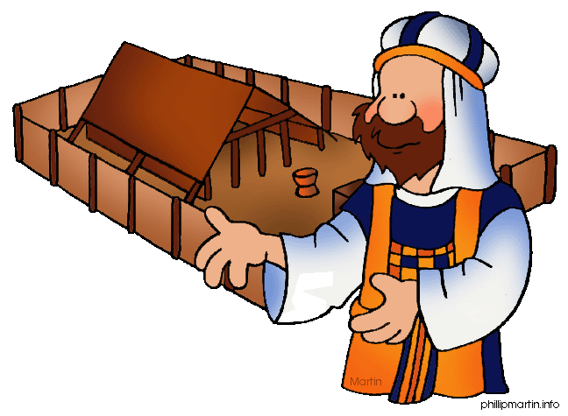**Message Outline**

*Leviticus: Healthcare Matters*

**Leviticus 12-15**

**Intro:** Feedback from Leviticus series…

* Temporary laws in the OT…

-Distinction between Civil, Ceremonial, and Moral Laws…

-Dietary laws in OT (cf. Gen.9:3, Mk.7:14- 23, Rom.14:14-21, Acts 10:9-16).

* Leviticus 11-15 includes many Ceremonial “clean/unclean” laws (not sinless/sinful)…

**12:1-5—**God-given “maternity” care…

* 8th day and Vitamin K in boys…
* Theories about extended maternity care…

**v.6-8—**First step after maternity leave…go to church!!!

* Why a burnt offering and sin offering? (cf. Ps.51:5, Rom.5:12-14).

**13:1-8—**Public health for skin diseases…

**v.40—**Clean to be Mr. Clean!!!

**v.41-46—**Stopping the spread of infections…

* Remember Jesus in NT breaks down Ceremonial Law while upholding Moral Law (Mk.1:40ff., 7:14ff, Mt.5:17ff.)…

**v.47-59—**Awareness of even material articles.

**14:1-32—**Cleansing of skin diseases/ritual…

**v.33-57—**Home observation, renovation, and/or destruction for mold/mildew…

**15:1-33—**Hygiene for bodily discharges…

* Both personally intimate and pragmatic…

**Lessons on Leviticus**

1) ___________________________________

* Cleanliness not the same as sinfulness…

2) ___________________________________

* Practical laws for healthy living…

3) ___________________________________

* Commanded to be aware of life all around..

4) ___________________________________

* Babies, skin, clothes, homes…all calls us to consider God in the happenings of life!

**Message Outline**

*Leviticus: Healthcare Matters*

**Leviticus 12-15**

**Intro:** Feedback from Leviticus series…

* Temporary laws in the OT…

-Distinction between Civil, Ceremonial, and Moral Laws…

-Dietary laws in OT (cf. Gen.9:3, Mk.7:14- 23, Rom.14:14-21, Acts 10:9-16).

* Leviticus 11-15 includes many Ceremonial “clean/unclean” laws (not sinless/sinful)…

**12:1-5—**God-given “maternity” care…

* 8th day and Vitamin K in boys…
* Theories about extended maternity care…

**v.6-8—**First step after maternity leave…go to church!!!

* Why a burnt offering and sin offering? (cf. Ps.51:5, Rom.5:12-14).

**13:1-8—**Public health for skin diseases…

**v.40—**Clean to be Mr. Clean!!!

**v.41-46—**Stopping the spread of infections…

* Remember Jesus in NT breaks down Ceremonial Law while upholding Moral Law (Mk.1:40ff., 7:14ff, Mt.5:17ff.)…

**v.47-59—**Awareness of even material articles.

**14:1-32—**Cleansing of skin diseases/ritual…

**v.33-57—**Home observation, renovation, and/or destruction for mold/mildew…

**15:1-33—**Hygiene for bodily discharges…

* Both personally intimate and pragmatic…

**Lessons on Leviticus**

1) ___________________________________

* Cleanliness not the same as sinfulness…

2) ___________________________________

* Practical laws for healthy living…

3) ___________________________________

* Commanded to be aware of life all around..

4) ___________________________________

* Babies, skin, clothes, homes…all calls us to consider God in the happenings of life!

**Message Outline**

*Leviticus: Healthcare Matters*

**Leviticus 12-15**

**Intro:** Feedback from Leviticus series…

* Temporary laws in the OT…

-Distinction between Civil, Ceremonial, and Moral Laws…

-Dietary laws in OT (cf. Gen.9:3, Mk.7:14- 23, Rom.14:14-21, Acts 10:9-16).

* Leviticus 11-15 includes many Ceremonial “clean/unclean” laws (not sinless/sinful)…

**12:1-5—**God-given “maternity” care…

* 8th day and Vitamin K in boys…
* Theories about extended maternity care…

**v.6-8—**First step after maternity leave…go to church!!!

* Why a burnt offering and sin offering? (cf. Ps.51:5, Rom.5:12-14).

**13:1-8—**Public health for skin diseases…

**v.40—**Clean to be Mr. Clean!!!

**v.41-46—**Stopping the spread of infections…

* Remember Jesus in NT breaks down Ceremonial Law while upholding Moral Law (Mk.1:40ff., 7:14ff, Mt.5:17ff.)…

**v.47-59—**Awareness of even material articles.

**14:1-32—**Cleansing of skin diseases/ritual…

**v.33-57—**Home observation, renovation, and/or destruction for mold/mildew…

**15:1-33—**Hygiene for bodily discharges…

* Both personally intimate and pragmatic…

**Lessons on Leviticus**

1) ___________________________________

* Cleanliness not the same as sinfulness…

2) ___________________________________

* Practical laws for healthy living…

3) ___________________________________

* Commanded to be aware of life all around..

4) ___________________________________

* Babies, skin, clothes, homes…all calls us to consider God in the happenings of life!

 **Small Group**

**Reflection Questions**

(Please take time to ponder and pencil in

to prep for this week’s small group session.)

**WELCOME TO SMALL GROUPS!!!**

Purpose: To *build* our FAITH and our FRIENDSHIPS.

*(Faith and friendships are our focus. Building anything though takes time, effort, energy and it can sometimes be a messy process, but in the end, it’s all worth it ☺)*

*\*Take some time to catch up since summer by answering the below questions…*

*-What’s one thing you READ this summer?*

*-What’s one thing you WATCHED this summer?*

*-What’s one EVENT you attended this summer?*

*-What’s one FOOD you enjoyed this summer?*

*-What’s one thing you DISCOVERED ABOUT GOD this summer?*

*\*Review Small Group Ground Rules…*

*1) Contribute: Show up prepped up!*

*2) Confidentiality: What’s said in the group stays in the group!*

*3) Character: Be honest! Don’t pretend to be holier-than-thou, nor always a mess.*

*\*Watch: The Chosen Season 3 Trailer…*

[*https://www.youtube.com/watch?v=Y7z868kEl5s*](https://www.youtube.com/watch?v=Y7z868kEl5s)

 **Small Group**

**Reflection Questions**

(Please take time to ponder and pencil in

to prep for this week’s small group session.)

**WELCOME TO SMALL GROUPS!!!**

Purpose: To *build* our FAITH and our FRIENDSHIPS.

*(Faith and friendships are our focus. Building anything though takes time, effort, energy and it can sometimes be a messy process, but in the end, it’s all worth it ☺)*

*\*Take some time to catch up since summer by answering the below questions…*

*-What’s one thing you READ this summer?*

*-What’s one thing you WATCHED this summer?*

*-What’s one EVENT you attended this summer?*

*-What’s one FOOD you enjoyed this summer?*

*-What’s one thing you DISCOVERED ABOUT GOD this summer?*

*\*Review Small Group Ground Rules…*

*1) Contribute: Show up prepped up!*

*2) Confidentiality: What’s said in the group stays in the group!*

*3) Character: Be honest! Don’t pretend to be holier-than-thou, nor always a mess.*

*\*Watch: The Chosen Season 3 Trailer…*

[*https://www.youtube.com/watch?v=Y7z868kEl5s*](https://www.youtube.com/watch?v=Y7z868kEl5s)

 **Small Group**

**Reflection Questions**

(Please take time to ponder and pencil in

to prep for this week’s small group session.)

**WELCOME TO SMALL GROUPS!!!**

Purpose: To *build* our FAITH and our FRIENDSHIPS.

*(Faith and friendships are our focus. Building anything though takes time, effort, energy and it can sometimes be a messy process, but in the end, it’s all worth it ☺)*

*\*Take some time to catch up since summer by answering the below questions…*

*-What’s one thing you READ this summer?*

*-What’s one thing you WATCHED this summer?*

*-What’s one EVENT you attended this summer?*

*-What’s one FOOD you enjoyed this summer?*

*-What’s one thing you DISCOVERED ABOUT GOD this summer?*

*\*Review Small Group Ground Rules…*

*1) Contribute: Show up prepped up!*

*2) Confidentiality: What’s said in the group stays in the group!*

*3) Character: Be honest! Don’t pretend to be holier-than-thou, nor always a mess.*

*\*Watch: The Chosen Season 3 Trailer…*

[*https://www.youtube.com/watch?v=Y7z868kEl5s*](https://www.youtube.com/watch?v=Y7z868kEl5s)