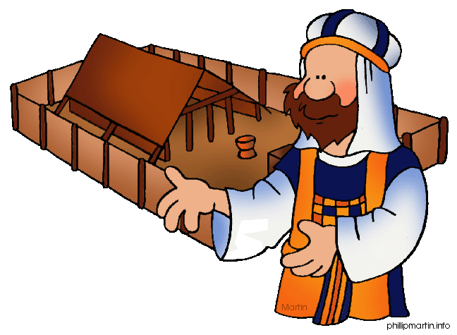
Message Outline
Leviticus: A Bad Day at the Office
Leviticus 10

Intro: Sources for Leviticus sermon series…
- Last week, the priesthood in Leviticus…
- “Priesthood of all believers” (cf.1Pet.3) and Leviticus application for Christians…
-YOU are a “priest”!!!
https://bibleproject.com/explore/video/royal-priesthood/

Read: Leviticus 10
- Remember from last week, God started the fire (9:23-24)!
- Significance of this fire (cf. 6:12-13)…
v.1-2—Playing with fire and getting burnt…
- What were Nadab and Abihu trying to accomplish???
v.3—Not pastoral, but poignant…Aaron
ponders…
v.4-5—Still in tunics…
v.6-7—Duty in the midst of sadness…
v.8-11—Alcohol tied into events???
v.12-20—Aaron’s answer for being unable to
eat…

Lessons from Leviticus

1) ___________________________________
- Our good is God’s glory…
- Westminster Shorter Catechism…chief end of man is to glorify God…
2) ___________________________________
- Toby Mac…our “show” is to spotlight God!
- Duty over emotions (v.6-7)…
- A lesson on drunkenness (v.8-11)…
3) ___________________________________
- Not just an OT story (cf. Acts 5, Mt.7:13-14, 1Pet.4:17)…
- Understanding sin from a Holy God’s perspective…

Message Outline
Leviticus: A Bad Day at the Office
Leviticus 10

Intro: Sources for Leviticus sermon series…
- Last week, the priesthood in Leviticus…
- “Priesthood of all believers” (cf.1Pet.3) and Leviticus application for Christians…
-YOU are a “priest”!!!
https://bibleproject.com/explore/video/royal-priesthood/

Read: Leviticus 10
- Remember from last week, God started the fire (9:23-24)!
- Significance of this fire (cf. 6:12-13)…
v.1-2—Playing with fire and getting burnt…
- What were Nadab and Abihu trying to accomplish???
v.3—Not pastoral, but poignant…Aaron
ponders…
v.4-5—Still in tunics…
v.6-7—Duty in the midst of sadness…
v.8-11—Alcohol tied into events???
v.12-20—Aaron’s answer for being unable to
eat…

Lessons from Leviticus

1) ___________________________________
- Our good is God’s glory…
- Westminster Shorter Catechism…chief end of man is to glorify God…
2) ___________________________________
- Toby Mac…our “show” is to spotlight God!
- Duty over emotions (v.6-7)…
- A lesson on drunkenness (v.8-11)…
3) ___________________________________
- Not just an OT story (cf. Acts 5, Mt.7:13-14, 1Pet.4:17)…
- Understanding sin from a Holy God’s perspective…

Message Outline
Leviticus: A Bad Day at the Office
Leviticus 10

Intro: Sources for Leviticus sermon series…
- Last week, the priesthood in Leviticus…
- “Priesthood of all believers” (cf.1Pet.3) and Leviticus application for Christians…
-YOU are a “priest”!!!
https://bibleproject.com/explore/video/royal-priesthood/

Read: Leviticus 10
- Remember from last week, God started the fire (9:23-24)!
- Significance of this fire (cf. 6:12-13)…
v.1-2—Playing with fire and getting burnt…
- What were Nadab and Abihu trying to accomplish???
v.3—Not pastoral, but poignant…Aaron
ponders…
v.4-5—Still in tunics…
v.6-7—Duty in the midst of sadness…
v.8-11—Alcohol tied into events???
v.12-20—Aaron’s answer for being unable to
eat…

Lessons from Leviticus

1) ___________________________________
- Our good is God’s glory…
- Westminster Shorter Catechism…chief end of man is to glorify God…
2) ___________________________________
- Toby Mac…our “show” is to spotlight God!
- Duty over emotions (v.6-7)…
- A lesson on drunkenness (v.8-11)…
3) ___________________________________
- Not just an OT story (cf. Acts 5, Mt.7:13-14, 1Pet.4:17)…
- Understanding sin from a Holy God’s perspective…

