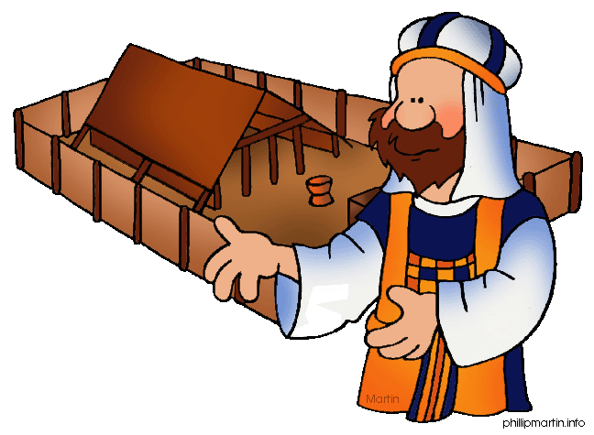
Message Outline
Leviticus: Priestly Principles
Leviticus 8-9

Intro: Leviticus sermon series…
- Last week, sacrifices! Why sacrifices?
1) ________________________________
2) ________________________________
- This week, the priesthood…

Biblical Backstory on the Priesthood
- In Genesis, little mentioned of priests…God working thru family units.
- In Exodus, God’s desire to make all people a “kingdom of priests” (Ex.19:6), but people resisted and wanted a rep instead (20:19).
- In NT, God back to Plan A...priesthood of all believers (1Pet.2:9) for followers of Jesus!!!
***Priestly principles are for all followers of
Jesus!

Read: Leviticus 8-9
8:1-4—Whole assembly…key sights/sounds to
take in (ie. clothes, oil, sacrifices, etc.)…
v.5-9—Significance of the garments (Ex.28)…
v.10-13—Significance of the oil (cf. Gen.28)...
v.14-30—Significance of the sacrifices…
v.31-36—Significance of the wait…
9:1-4—More sacrifices…a life of continual
atonement…
v.5-22—Vertical and horizontal significance…
v.23-24—God shows up!!!

Priestly Principles for YOU!

1) _____________________________8:5-9
- Christian dress code (cf. Col.3:12-14, Rom.13:12-14, Eph.6:13-17)…
2) _____________________________8:10-12
- Anointed for a purpose to connect heaven and earth…
3) _____________________________8:14-30
- Continual need to clear of sin…
4) _____________________________9:24
Message Outline
Leviticus: Priestly Principles
Leviticus 8-9

Intro: Leviticus sermon series…
- Last week, sacrifices! Why sacrifices?
1) ________________________________
2) ________________________________
- This week, the priesthood…

Biblical Backstory on the Priesthood
- In Genesis, little mentioned of priests…God working thru family units.
- In Exodus, God’s desire to make all people a “kingdom of priests” (Ex.19:6), but people resisted and wanted a rep instead (20:19).
- In NT, God back to Plan A...priesthood of all believers (1Pet.2:9) for followers of Jesus!!!
***Priestly principles are for all followers of
Jesus!

Read: Leviticus 8-9
8:1-4—Whole assembly…key sights/sounds to
take in (ie. clothes, oil, sacrifices, etc.)…
v.5-9—Significance of the garments (Ex.28)…
v.10-13—Significance of the oil (cf. Gen.28)...
v.14-30—Significance of the sacrifices…
v.31-36—Significance of the wait…
9:1-4—More sacrifices…a life of continual
atonement…
v.5-22—Vertical and horizontal significance…
v.23-24—God shows up!!!

Priestly Principles for YOU!

1) _____________________________8:5-9
- Christian dress code (cf. Col.3:12-14, Rom.13:12-14, Eph.6:13-17)…
2) _____________________________8:10-12
- Anointed for a purpose to connect heaven and earth…
3) _____________________________8:14-30
- Continual need to clear of sin…
4) _____________________________9:24
Message Outline
Leviticus: Priestly Principles
Leviticus 8-9

Intro: Leviticus sermon series…
- Last week, sacrifices! Why sacrifices?
1) ________________________________
2) ________________________________
- This week, the priesthood…

Biblical Backstory on the Priesthood
- In Genesis, little mentioned of priests…God working thru family units.
- In Exodus, God’s desire to make all people a “kingdom of priests” (Ex.19:6), but people resisted and wanted a rep instead (20:19).
- In NT, God back to Plan A...priesthood of all believers (1Pet.2:9) for followers of Jesus!!!
***Priestly principles are for all followers of
Jesus!

Read: Leviticus 8-9
8:1-4—Whole assembly…key sights/sounds to
take in (ie. clothes, oil, sacrifices, etc.)…
v.5-9—Significance of the garments (Ex.28)…
v.10-13—Significance of the oil (cf. Gen.28)...
v.14-30—Significance of the sacrifices…
v.31-36—Significance of the wait…
9:1-4—More sacrifices…a life of continual
atonement…
v.5-22—Vertical and horizontal significance…
v.23-24—God shows up!!!

Priestly Principles for YOU!

1) _____________________________8:5-9
- Christian dress code (cf. Col.3:12-14, Rom.13:12-14, Eph.6:13-17)…
2) _____________________________8:10-12
- Anointed for a purpose to connect heaven and earth…
3) _____________________________8:14-30
- Continual need to clear of sin…
4) _____________________________9:24

Priestly
Breastplate

*Who do you rep before the Lord?

²¹ There are to be twelve stones, one for each of the names of the sons of Israel, each engraved like a seal with the name of one of the twelve tribes….²⁹ “Whenever Aaron enters the Holy Place, he will bear the names of the sons of Israel over his heart on the breastpiece of decision as a continuing memorial before the Lord.
-Exodus 28:21, 29 NIV

Priestly
Breastplate

*Who do you rep before the Lord?

²¹ There are to be twelve stones, one for each of the names of the sons of Israel, each engraved like a seal with the name of one of the twelve tribes….²⁹ “Whenever Aaron enters the Holy Place, he will bear the names of the sons of Israel over his heart on the breastpiece of decision as a continuing memorial before the Lord.
-Exodus 28:21, 29 NIV

Priestly
Breastplate

*Who do you rep before the Lord?

²¹ There are to be twelve stones, one for each of the names of the sons of Israel, each engraved like a seal with the name of one of the twelve tribes….²⁹ “Whenever Aaron enters the Holy Place, he will bear the names of the sons of Israel over his heart on the breastpiece of decision as a continuing memorial before the Lord.
-Exodus 28:21, 29 NIV

