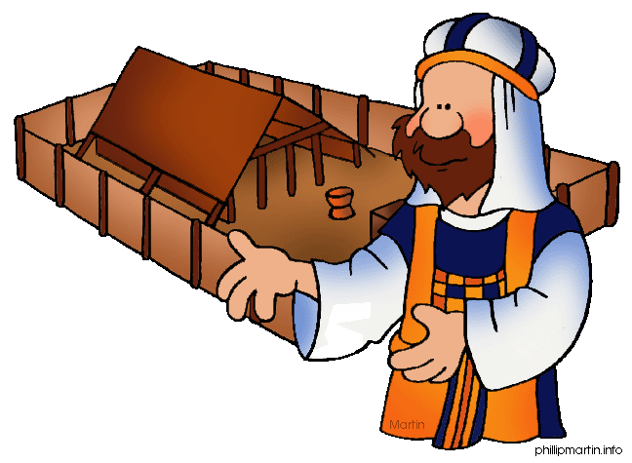
Message Outline
Leviticus: Sacrifices
Leviticus 1-7

Intro: New sermon series on Leviticus!!!
- Last week…the groundwork for how to rightly interpret Scripture (cf.2Tim.3:16)…
-Understanding Civil Law, Ceremonial Law, and Moral Law in the OT…
*Moral Laws consistent in OT and NT and thus still to be consistent for Christians today…other laws were changed/fulfilled.
- Today, sacrifices in Leviticus 1-7…
(cf. https://www.gotquestions.org/Old-Testament-sacrifices.html)

*Why sacrifices?
a) Takes seriously that sin leads to death (cf.Rom.3:23)
b) Teaches substitutionary atonement
c) Echoes back to Eden (Gen.3:21) and forward to Jesus (Jn.1:29, Heb.7:27)…

Read: Leviticus 1
v.1—“from the tent of meeting” to “in the tent of
meeting” (Lev.1:1, Num.1:1)…
- Leviticus teaches how to be brought near to the presence of God…
v.1-3—“without defect”…bring God your best!
v.3-9—“You must…you are…”: church in
Leviticus is personal and interactive!
- “food offering”: for priest’s needs, not God’s (cf. Ps.50:7-15)…
- “aroma pleasing to the Lord”: the scent of sacrifice pleases God (cf. Eph.5:2)…
v.10-17—“herds, flocks, birds” shows different
economic levels, but same acceptance by God…

Lessons from Leviticus 1-7
- Understanding life outside the “Bassett’s Bubble”…
1) ___________________________________v.2
- We have a role to play in our relationship with God (Eph.2:8-10, Phil.2:12-13)…
2) ___________________________________v.9
3) ___________________________________v.3ff
4) _______________________________v.3,10,14
Message Outline
Leviticus: Sacrifices
Leviticus 1-7

Intro: New sermon series on Leviticus!!!
- Last week…the groundwork for how to rightly interpret Scripture (cf.2Tim.3:16)…
-Understanding Civil Law, Ceremonial Law, and Moral Law in the OT…
*Moral Laws consistent in OT and NT and thus still to be consistent for Christians today…other laws were changed/fulfilled.
- Today, sacrifices in Leviticus 1-7…
(cf. https://www.gotquestions.org/Old-Testament-sacrifices.html)

*Why sacrifices?
a) Takes seriously that sin leads to death (cf.Rom.3:23)
b) Teaches substitutionary atonement
c) Echoes back to Eden (Gen.3:21) and forward to Jesus (Jn.1:29, Heb.7:27)…

Read: Leviticus 1
v.1—“from the tent of meeting” to “in the tent of
meeting” (Lev.1:1, Num.1:1)…
- Leviticus teaches how to be brought near to the presence of God…
v.1-3—“without defect”…bring God your best!
v.3-9—“You must…you are…”: church in
Leviticus is personal and interactive!
- “food offering”: for priest’s needs, not God’s (cf. Ps.50:7-15)…
- “aroma pleasing to the Lord”: the scent of sacrifice pleases God (cf. Eph.5:2)…
v.10-17—“herds, flocks, birds” shows different
economic levels, but same acceptance by God…

Lessons from Leviticus 1-7
- Understanding life outside the “Bassett’s Bubble”…
1) ___________________________________v.2
- We have a role to play in our relationship with God (Eph.2:8-10, Phil.2:12-13)…
2) ___________________________________v.9
3) ___________________________________v.3ff
4) _______________________________v.3,10,14
Message Outline
Leviticus: Sacrifices
Leviticus 1-7

Intro: New sermon series on Leviticus!!!
- Last week…the groundwork for how to rightly interpret Scripture (cf.2Tim.3:16)…
-Understanding Civil Law, Ceremonial Law, and Moral Law in the OT…
*Moral Laws consistent in OT and NT and thus still to be consistent for Christians today…other laws were changed/fulfilled.
- Today, sacrifices in Leviticus 1-7…
(cf. https://www.gotquestions.org/Old-Testament-sacrifices.html)

*Why sacrifices?
a) Takes seriously that sin leads to death (cf.Rom.3:23)
b) Teaches substitutionary atonement
c) Echoes back to Eden (Gen.3:21) and forward to Jesus (Jn.1:29, Heb.7:27)…

Read: Leviticus 1
v.1—“from the tent of meeting” to “in the tent of
meeting” (Lev.1:1, Num.1:1)…
- Leviticus teaches how to be brought near to the presence of God…
v.1-3—“without defect”…bring God your best!
v.3-9—“You must…you are…”: church in
Leviticus is personal and interactive!
- “food offering”: for priest’s needs, not God’s (cf. Ps.50:7-15)…
- “aroma pleasing to the Lord”: the scent of sacrifice pleases God (cf. Eph.5:2)…
v.10-17—“herds, flocks, birds” shows different
economic levels, but same acceptance by God…

Lessons from Leviticus 1-7
- Understanding life outside the “Bassett’s Bubble”…
1) ___________________________________v.2
- We have a role to play in our relationship with God (Eph.2:8-10, Phil.2:12-13)…
2) ___________________________________v.9
3) ___________________________________v.3ff
4) _______________________________v.3,10,14

