 **Message Outline**

*Summer Stories:*

*The Three Little Pigs*

**Intro:** Kid’s books as a lead in for The Book!

* *The Giving Tree* and a life of JOY—Jesus, Others, Yourself…
* *The Very Hungry Caterpillar* and life’s hungers: physical, spiritual, mental…
* *Too Much Noise* and how to handle the noise of life with Jesus’ practice of solitude…

The Three Little Pigs

Pig # 1 Beliefs….

Pig # 2 Beliefs….

Pig # 3 Beliefs…..

Life Mottos

Pig 1) _______________________________

Pig 2) ________________________________

Pig 3) ________________________________

 **Message Outline**

*Summer Stories:*

*The Three Little Pigs*

**Intro:** Kid’s books as a lead in for The Book!

* *The Giving Tree* and a life of JOY—Jesus, Others, Yourself…
* *The Very Hungry Caterpillar* and life’s hungers: physical, spiritual, mental…
* *Too Much Noise* and how to handle the noise of life with Jesus’ practice of solitude…

The Three Little Pigs

Pig # 1 Beliefs….

Pig # 2 Beliefs….

Pig # 3 Beliefs…..

Life Mottos

Pig 1) _______________________________

Pig 2) ________________________________

Pig 3) ________________________________

 **Message Outline**

*Summer Stories:*

*The Three Little Pigs*

**Intro:** Kid’s books as a lead in for The Book!

* *The Giving Tree* and a life of JOY—Jesus, Others, Yourself…
* *The Very Hungry Caterpillar* and life’s hungers: physical, spiritual, mental…
* *Too Much Noise* and how to handle the noise of life with Jesus’ practice of solitude…

The Three Little Pigs

Pig # 1 Beliefs….

Pig # 2 Beliefs….

Pig # 3 Beliefs…..

Life Mottos

Pig 1) _______________________________

Pig 2) ________________________________

Pig 3) ________________________________

**God Made Us a Family**

**Pastor:** God made us a family.

**Church:** *We need one another. We love one another. We forgive one another.*

**Pastor:** God made us a family.

**Church:** *We work together. We play together. We worship together.*

**Pastor:** God made us a family.

**Church:** *Together we use God’s Word. Together we grow in Christ. Together we love all people.*

**Pastor:** God made us a family.

**Church:** *Together we serve our God. Together we hope for heaven.*

**ALL:** *These are our hopes and ideals. Help us to attain them, O God, through Jesus Christ our Lord.*

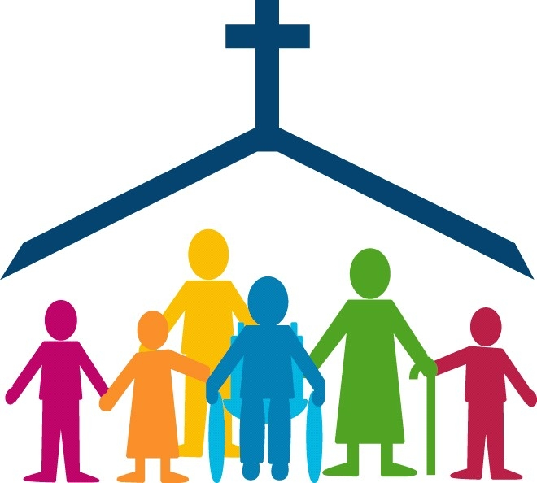

**God Made Us a Family**

**Pastor:** God made us a family.

**Church:** *We need one another. We love one another. We forgive one another.*

**Pastor:** God made us a family.

**Church:** *We work together. We play together. We worship together.*

**Pastor:** God made us a family.

**Church:** *Together we use God’s Word. Together we grow in Christ. Together we love all people.*

**Pastor:** God made us a family.

**Church:** *Together we serve our God. Together we hope for heaven.*

**ALL:** *These are our hopes and ideals. Help us to attain them, O God, through Jesus Christ our Lord.*



**God Made Us a Family**

**Pastor:** God made us a family.

**Church:** *We need one another. We love one another. We forgive one another.*

**Pastor:** God made us a family.

**Church:** *We work together. We play together. We worship together.*

**Pastor:** God made us a family.

**Church:** *Together we use God’s Word. Together we grow in Christ. Together we love all people.*

**Pastor:** God made us a family.

**Church:** *Together we serve our God. Together we hope for heaven.*

**ALL:** *These are our hopes and ideals. Help us to attain them, O God, through Jesus Christ our Lord.*

